Open VScode, click on the branch at the bottom.

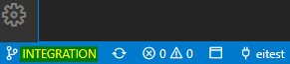

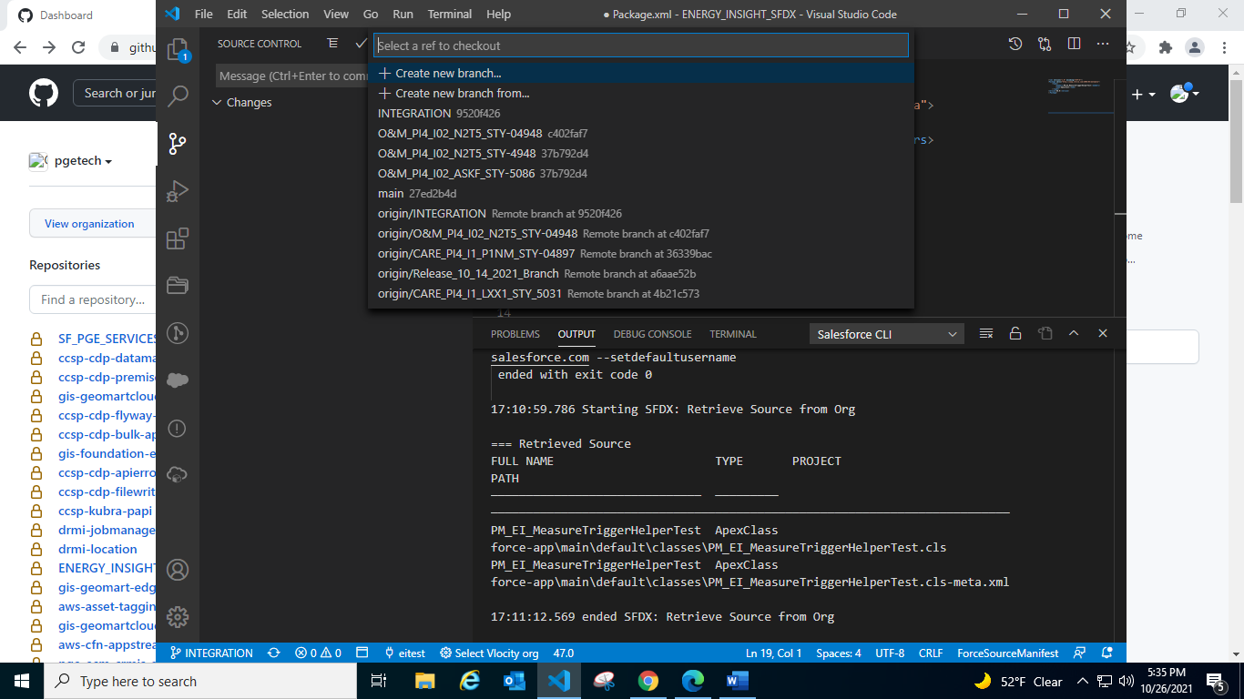

Select ‘Create new branch from’ option. Enter the name of the branch and press Enter then enter the ref branch ‘origin/main’.

Publish the branch, there is a cloud like icon besides the branch name. (Authorize the org from which the changes are to be retrieved).

Copy the components in the xml file. Save the file.

Right Click on the xml file in the explorer and select as shown in below image:

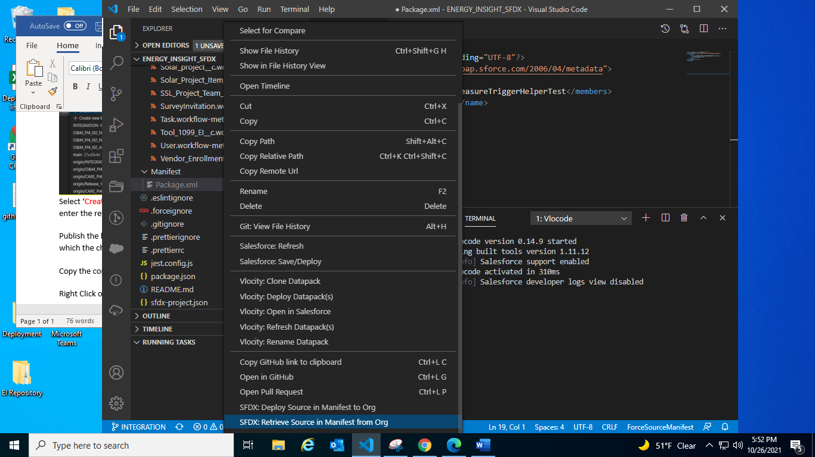

Go to Changes icon in the left side.

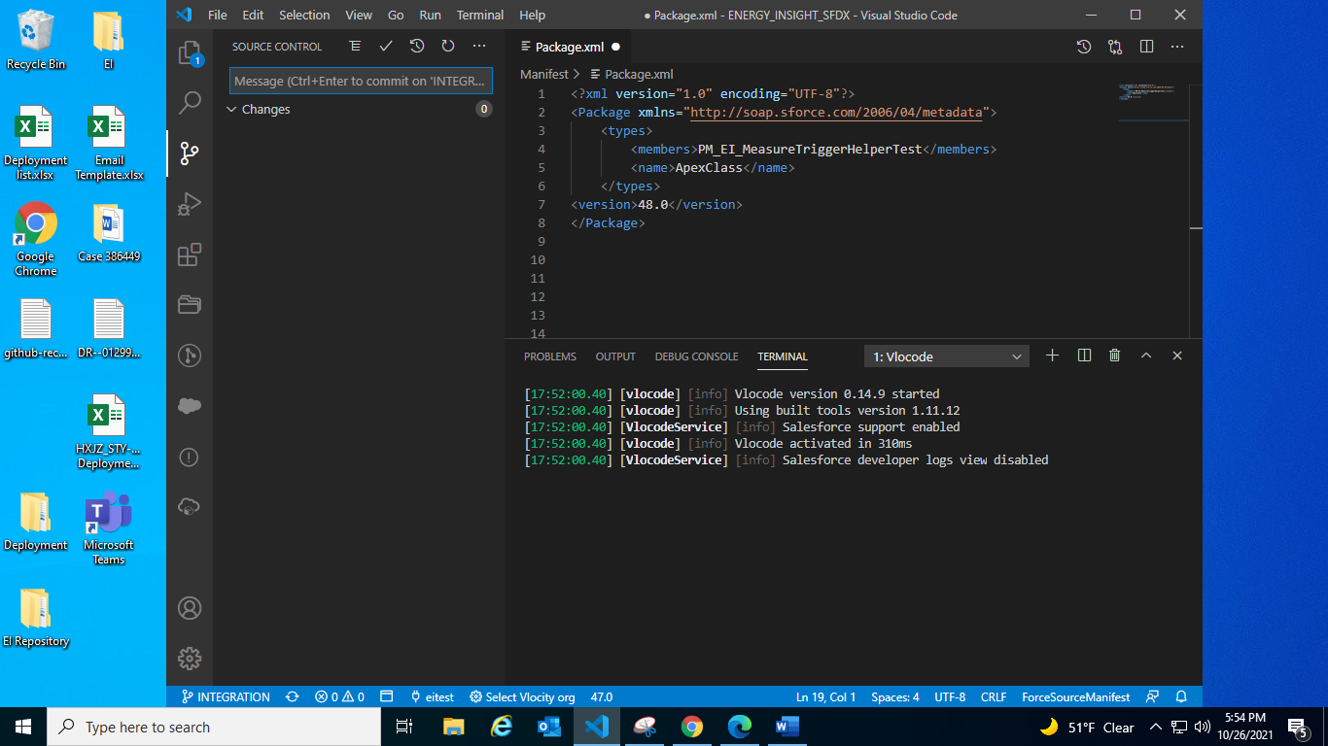

Later Stage the changes by clicking on “+” sign and commit the changes by clicking on right tick at the top.

Then click on the cloud button again to publish the changes.

Now, change the branch to Integration

Press Ctrl + Shift + P

Select Git Merge and select the branch to be merged (newly created story branch)

Again click on the cloud icon and push the changes.